Francisco Rodriguez

World History 1

Professor Edwards

11-18-2017

A Game for the Thrones

The journey to power comes with its costs and antics. For one to be crowned Emperor, it is required of him or her to have a series of achievements both politically and socially. Once people have got trust in you and believed that you could deliver up to their expectations, then you become the most preferred leader of their choice. Settling for the best policies facilitate the enhancement of good reputation as a leader. Physical execution of the made policies by a leader attracts his or her subjects into doing the same. This implies that leadership is practical and not theoretical; it is rather an execution of what is put on theory. The most important thing for a good leader is the writing of a good legacy. The reputation that you live after your exit is momentous; it raises the question whether people will remember you for good or bad.  To write the best legacy, the leadership strategy should aim at making your government an all-inclusive ruler ship. By embracing this fact, the subjects under a leader celebrate his reign because resistance can never overcome the sovereignty of the people. The history of Augustus Caesar’s predecessor, Julius Caesar, was as a politician among the Romans and a general who lead wars that resulted in the establishment of the Roman Empire.  Apart from being a general, Julius was also a renowned prose writer in ancient Rome (1-Shotter, 2005). Julius made several attempts which were in a bid to facilitate him to attain massive power over a big part of the earth. He did this by coming up with a political alliance which was resisted by people who were optimistic among the Romans. This was done by the Roman senate in 60 BCE (2-Shotter, 2005).  During his reign Caesar made various achievements, one of them was winning the Gallic wars which caused the expansion of Rome to several parts of the English world. In 51 BCE Caesar became the first general who could get to the British channel as well as build a bridge that linked Rome to Britain. He used this bridge to attack England and attack it. When the Gallic wars were completed the Roman Senate ordered Julius to quit his post in the military. However, Cesar rebelled against this order, and he went on to stay on the battlefield. This resulted in Julius getting into Roman Italy illegally while armed. The civil war that erupted gave Julius Cesar massive military power and political influence because he could win this civil war. He later assumed control of the government, and he immediately began social reforms to reshape Rome. However, even with his rule, some certain ethnic conflicts had not been resolved. After taking over from Julius Cesar, (3-Robert, 2016). Augustus became the first Roman emperor and in forty years’ peace and wealth reined in Rome on his account. The Roman army kept peace with everyone during this period which resulted in the great progress that Rome made during this time. There was a remarkable step that was made regarding infrastructure and trade. There was a rise in the number of scholars and the level of literature that was written during Augusts’ time and this was because of his good leadership that remained remarkable for over two hundred years. He is widely known as the father of the “Roman peace” or rather “Pax Romana.” Augustus Caesar began the journey to his reign at the age of eighteen after the death of his great-uncle, Julius Caesar. It was not instant though; he had to take back the city of Rome from Marc Antony. Marc was a part of the assassination of Julius Caesar which gave him the power of Rome. He had also married Augustus sister Octavia but left her side for Cleopatra, the Pharaoh of Egypt. Amid all this backstabbing, Augustus went through many trials that not only got him the great city of Rome back; he also triumphed over Egypt and claimed it as his own. The battle of Actium got rid of Marc Antony and his un-Rome like love affair for Cleopatra which disturbed the Roman Senate and the Roman people who fought alongside Augustus Caesar. Augustus Caesar could overthrow Marc Antony at the Battle of Actium because of his one thousand warships which outnumbered Antony’s five hundred. Alongside these overwhelming numbers, Marc Antony had an embarrassing reputation in war compared to Augustus’ strategic dominance in war, which is why Augustus won the battle. Augustus battle with Marc was not only in military form but also political. To gain superiority, Augustus engaged himself in Anti-Marc Antony political campaigns which made people give him more attention than Marc from the Romans. Augustus was wise to allow share half of the land they had conquered after avenging the assassination of Julius Caesar. By doing this Augustus garnered a military that was strong which gained him a strong and powerful military, therefore he could overthrow March’s ruler ship.  After seeing defeat in war, Marc and Cleopatra killed themselves (4- Robert, 2016) and this led to Augustus taking over the land of Egypt and made it part of Rome. Back in Rome Augustus having been a man who was just in his early thirties was recognized by the people as a hero. This was because despite his young age he could wipe out his enemies successfully which made him conquer other lands that were different from Rome and was able to make them part of Rome.  Augustus promised his people peace and unity because the war dust had now been settled. The battlefield had not been so easy for him, but the driving force in him preferred winning instead of losing a battle which would have plunged Rome into jeopardy. Augustus divorced his wife and married his expectant mistress who was known as Livia. The people who opposed him had the feeling that Augustus was formulating a strategy in which he would establish a dynasty which would enable him to govern Rome for the rest of his years. Augustus had a well laid out strategy that would enable him to establish a dynasty without raising any eyebrows from the Rome political fraternity. He pretended to give up power; this was a calculated move that Augustus knew would draw the attention of the Senate together with the people. After that, his pretense a sequence of disasters engulfed Rome which then led to panic among the people. The only person the people saw as the savior was Augustus, (5-Shotter, 2005) to them he was the only one who could salvage them from the situation they were in, and so they begged the Senate to make him the absolute ruler. He agreed to this offer though he did not disclose his motives, he was able to buy the thoughts of the people by telling them he was a ruler that was aiming at upholding the Roman traditions; in a real sense, Augustus was using this office to create a dynasty for himself. Augustus saw religion as the only way he could defend his position having fought his way into power. Religion was also instrumental in Augustus’ rule to spearhead his political agenda. This was a move that Augustus was sure would make it hard for his enemies to overthrow him since he could not stand seeing himself as a loser and so, had to use every possible means to ensure that his reign is protected from any interference. Traditionally Emperors were revered in Rome (6-Robert, 2016) but this seemed not to be enough for Augustus, he wanted to make the people see him as a supreme being. The Roman Empire was composed of many gods and deities and so the emperor opted to make himself one of the gods so that he would achieve his objectives. To the Romans this was a usual step since they had the culture of turning their leaders into gods whether dead or alive so long as they saw it fit to refer to their leaders as gods. There were certain supernatural things that transpired and Augustus claimed to have knowledge of their existence. At the time, Halley’s Comet passed over Rome, Augustus told the people that it was Julius Cesar’s spirit. He referred to his predecessor as a god thus this also made him declare himself a god since the one who came before him was a god (Bourne, 2000). This he did to make sure that the people recognized him as a god and not just as any other normal ruler. Using religion as a tool, Augustus ensured that he portrayed his ‘humbleness ‘regardless if he was born into a prestigious family (7-Edmondson, 2009). To ensure this he told the people of what he did during fasting, the types of food he ate during fasting, and he also ensured that the public heard of how his family was committed when it came religious matters. Augustus was using this strategy to ensure that he remained in power in any way. He had faked humility so that he would gain favor before the eyes of the people and this gave him time to establish his dynasty in a peaceful way which no one would have suspected (8-Clifford, 2000). During this time, Augustus was also keen to engage in deeds that gave him good reputation (9-Shotter, 2005). He restored the old traditions of the Romans and he renovated eighty-two temples. He did this to showcase his commitment to the religious aspects of the empire. By doing this he gained the favor that he desired from people and thus his biggest security was the people of Rome. He recovered Rome’s lost glory and restored back the pride that Romans enjoyed. In 12 CE (10-Robert, 2016) Augustus made himself the High Priest of Rome, he restored the social and religious traditions that had been subverted by other rulers. He re-introduced the sacrificing of animals to the gods. This was not only done by him but it was done by everyone who was within the constraints of the Roman Empire. Through leading by example the Emperor could win the heart of many who emulated him thus encrypting his name into their hearts and mind.   The people believed in whatever Augustus did and they believed that he was a true leader, one who had been given the mantle of restoring the true calling of Rome. The Romans believed that they were superior to any other state and that is why they had conquered Spain and many other states. They were the supreme authority that was in place during this time, and they enjoyed all this under the ruler ship of Augustus thus they revered him and respected him.  By this time, Augustus had achieved all these achievements; it was time that he was now ready to get into power. One of the eventualities that he faced after getting into power was that his daughter became notorious in the Empire and so he had no option other than to banish her from Rome. However, despite all these challenges, Augustus had achieved the desires of his heart by the time he had ascended the throne. He had fought many battles which brought in the redemption of Rome and its reputation (11- Woolf, 2007).  The strategies that Augustus employed to get into power were successful. His wise approach towards this journey to power helped him avoid confrontations by the Senate because none of the members of that house would have suspected the actual plan of Augustus (12- John, 1990) . When one acquires social influence, he works to translate it into political influence which later gives them political power after they establish their dynasties. This is the notion that Augustus had till the first day that he was crowned emperor of Rome (13- Shelton, 1998).

References

Blackburn, B. (1999). The Oxford Companion to the Year. Oxford University Press: Reprinted with corrections.

Bourne, Ella (Bourne, 2000). "Augustus as a Letter-Writer", Transactions and Proceedings of the American Philological Association (Volume 49, 1918): 53–66.

Bowersock,. W. (1990). "The Pontificate of Augustus": ISBN 978-0-520-08447-6.    
Clifford, A. (2000) Imperial ideology and provincial loyalty in the Roman Empire: University of California Press.

Edmondson, Jonathan. Augustus, Edinburgh University Press (2009) ProQuest EBook Central,  
https://ebookcentral.proquest.com/lib/nddn-ebooks/detail.action?docID=536992.  
John C. (1990). Longman pronunciation dictionary. Harlow, England: Longman. ISBN 0-582-05383-8. entry "Augustus"

Maria, B. (2006). The Persians: An Introduction. London & New York: Routledge. ISBN 978-0-415-32089-4

Robert, W. (2016) Ways of the World: a brief global history: 3rd ed., Bedford Bks St. Martins  
Shelton, J. (1998) As the Romans Did (Oxford University Press, 1998), 58.  
Shotter, D. Augustus C. Taylor and Francis, (2005) ProQuest EBook Central,https://ebookcentral.proquest.com/lib/nddn-ebooks/detail.action?docID=214726.  
Woolf, G. (2007). Ancient civilizations: the illustrated guide to belief, mythology, and art. Barnes & Noble. p. 397. E Book, http://sflib1.sfpl.org/record=b2158256~S1

Citation 7 and reference- Edmondson, Jonathan. Augustus, Edinburgh University Press (2009) <https://books.google.co.ke/books?id=G0vmCQAAQBAJ&printsec=frontcover#v=onepage&q&f=false> pp 7

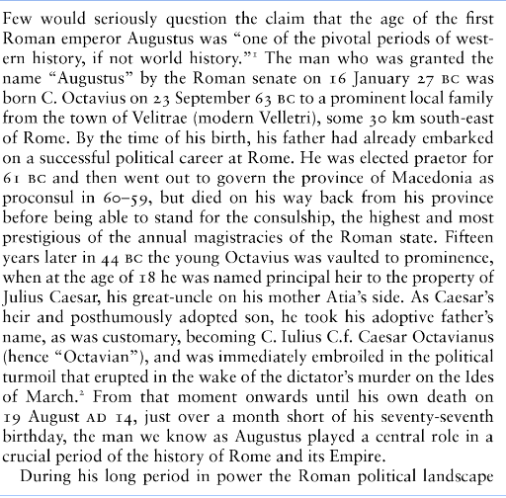

Citation 1,2,5 and reference - Shotter, David. Augustus C. Taylor and Francis, (2005) ProQuest Ebook Central,https://ebookcentral.proquest.com/lib/nddn-ebooks/detail.action?docID=214726, pp 4

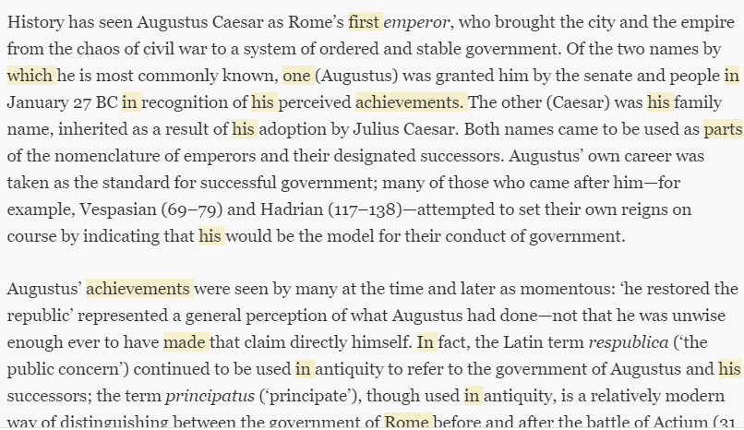

Citations – 3,4,6 Robert, W. (2016) Ways of the World: a brief global history: 3rd ed., Bedford Bks St. Martins

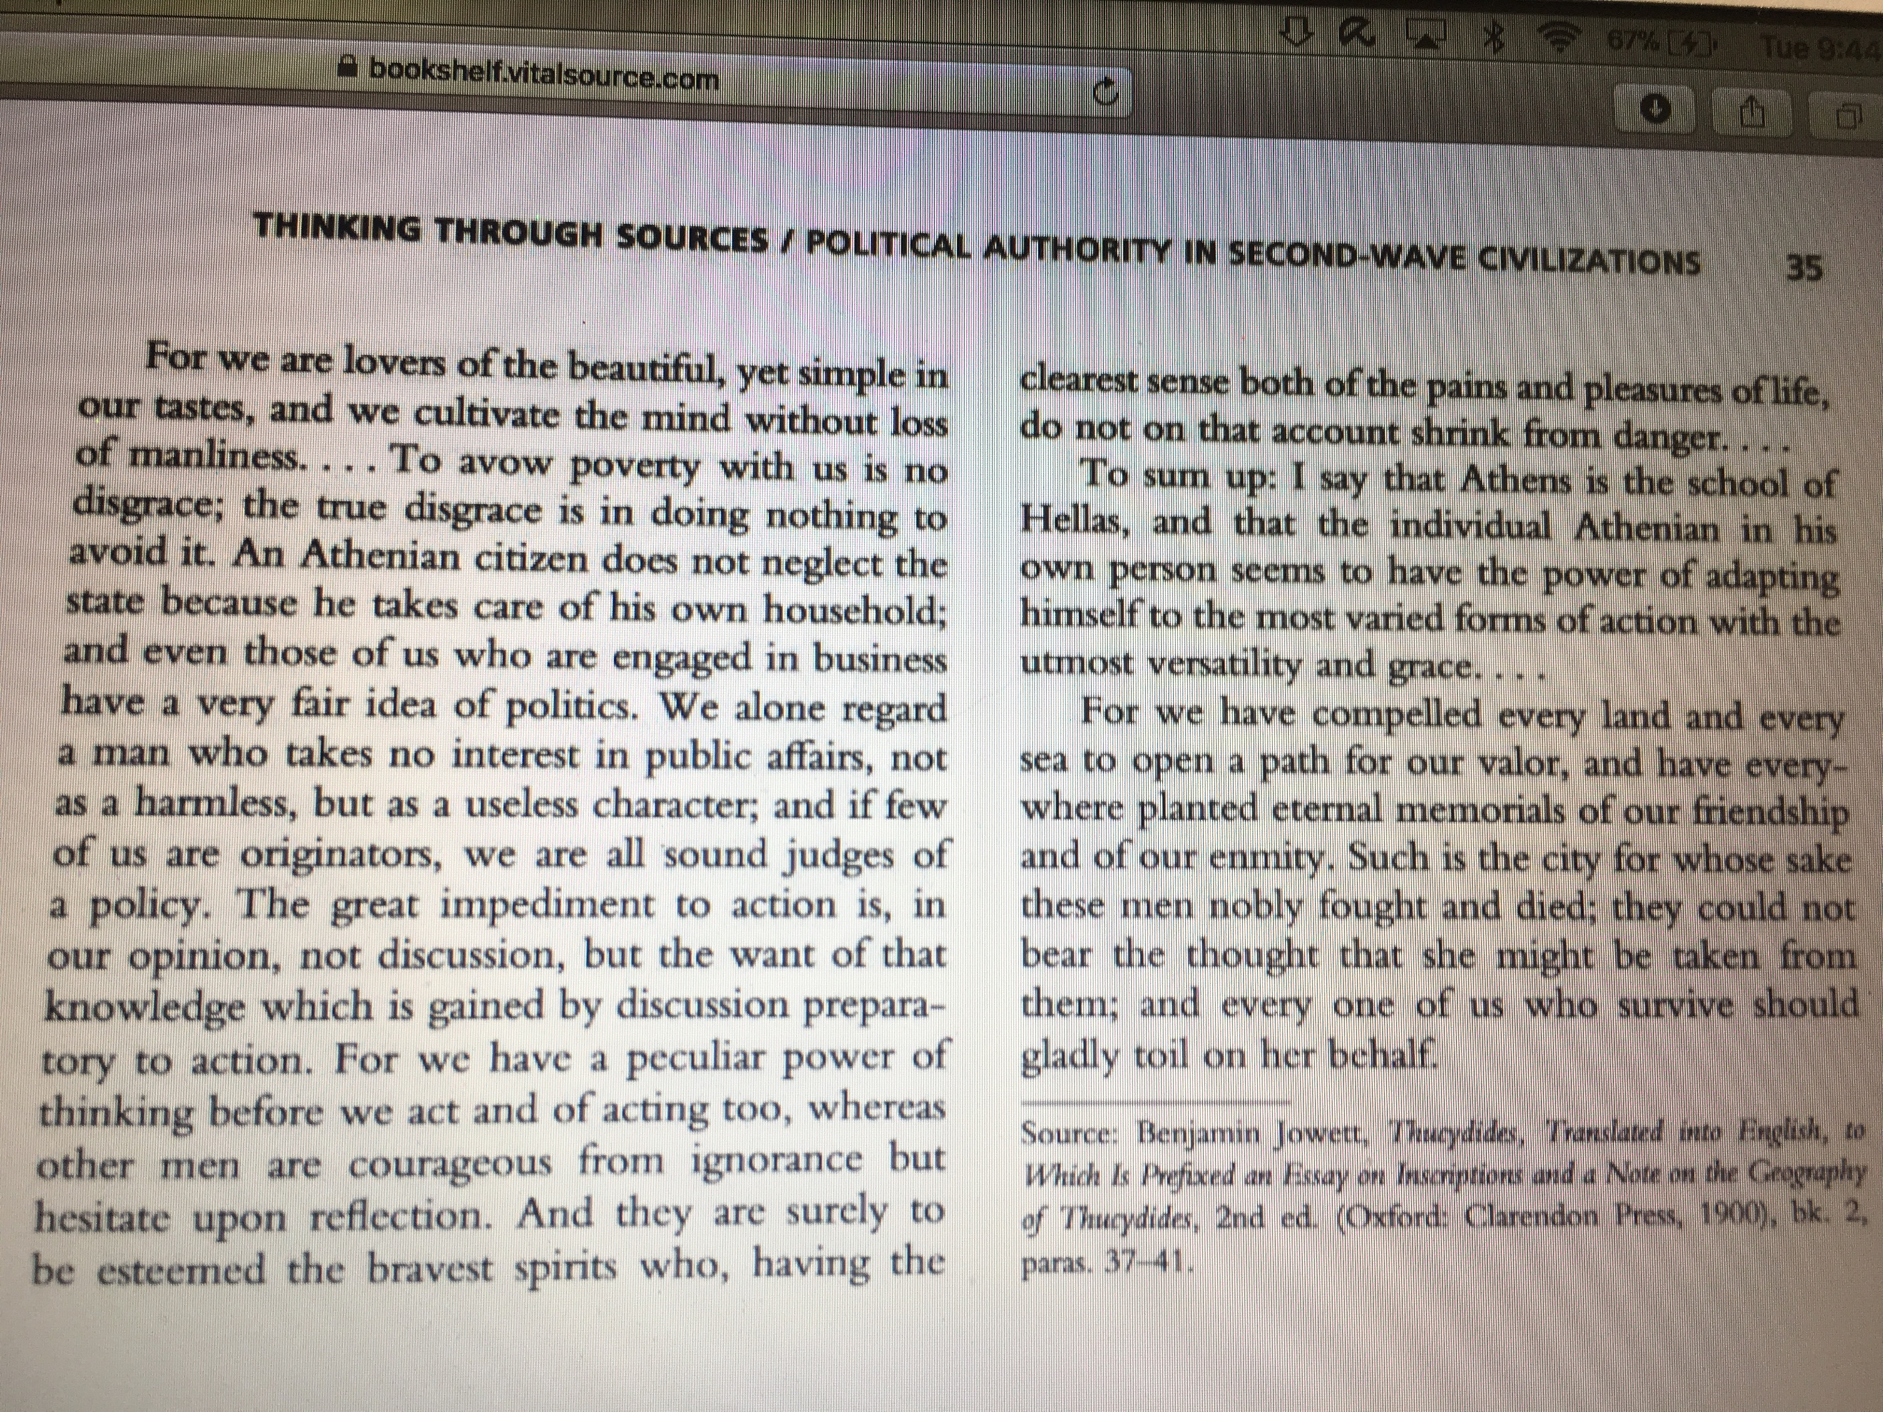

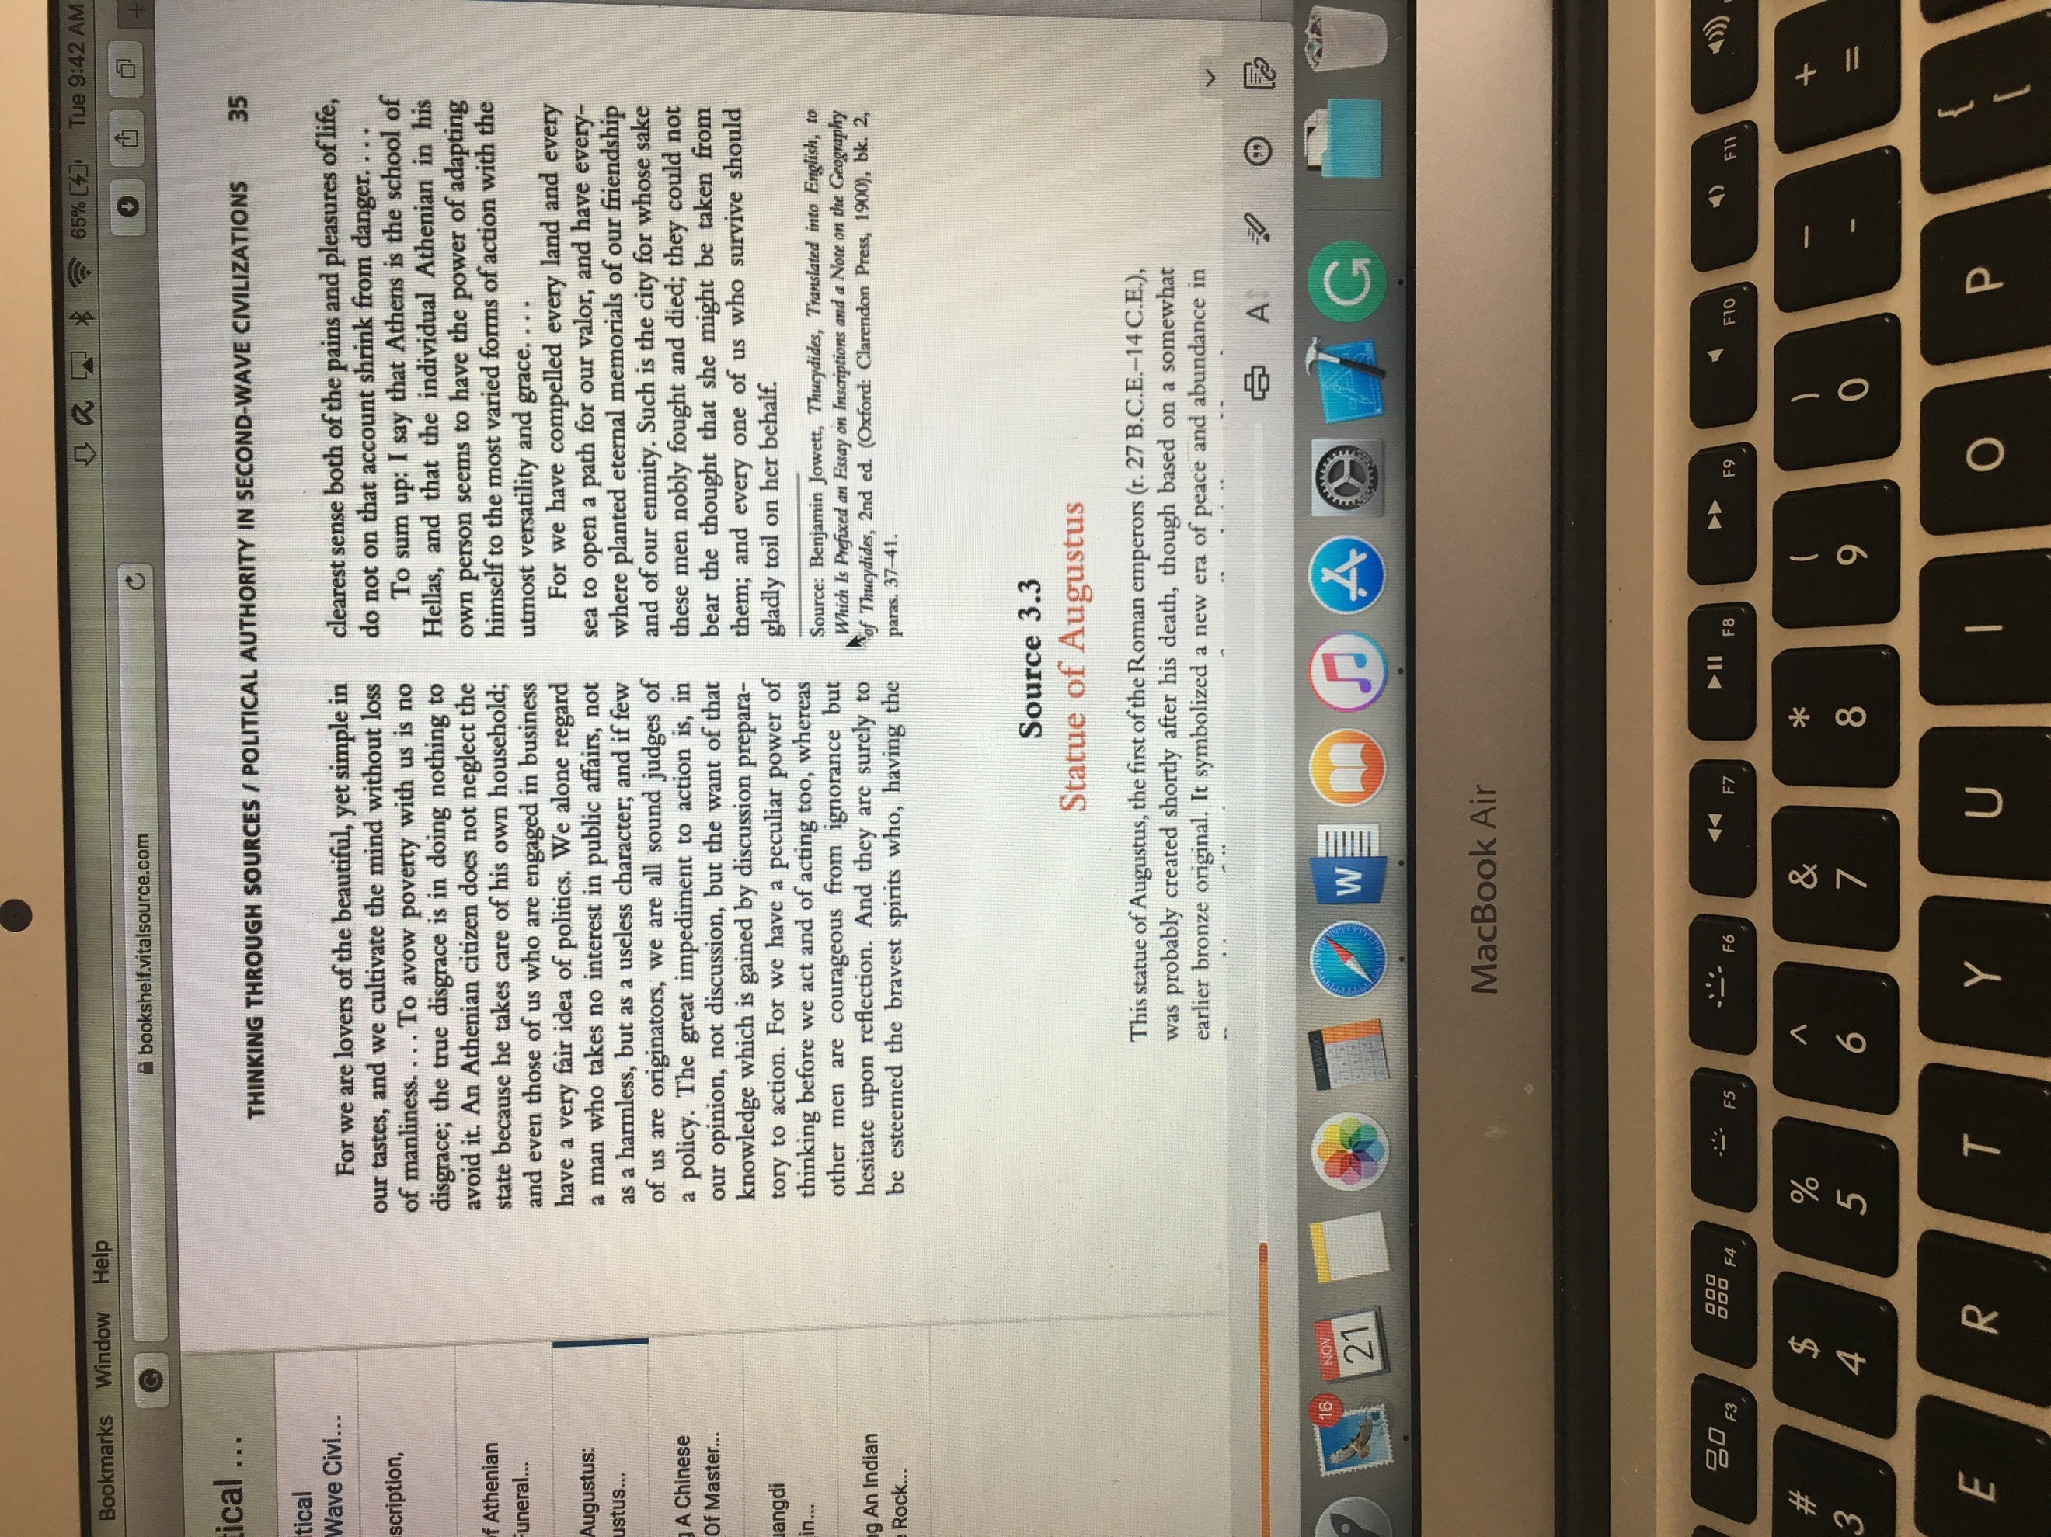

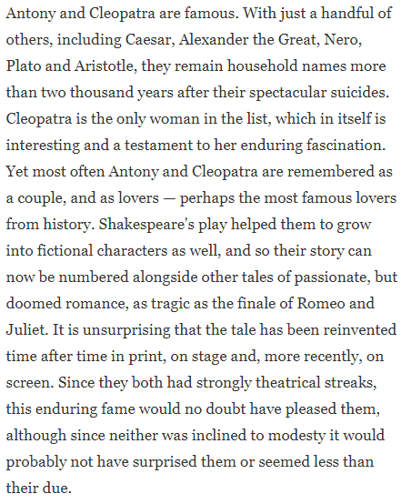

Citation 13 - Shelton, Jo-Ann. (1998) As the Romans Did (Oxford University Press, 1998), 58.

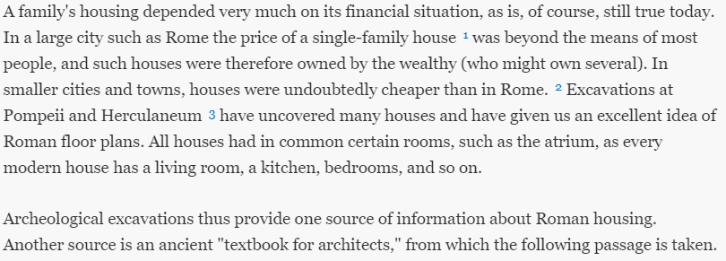

Citation 11 - Woolf, G. (2007). Ancient civilizations: the illustrated guide to belief, mythology, and art. Barnes & Noble pp. 397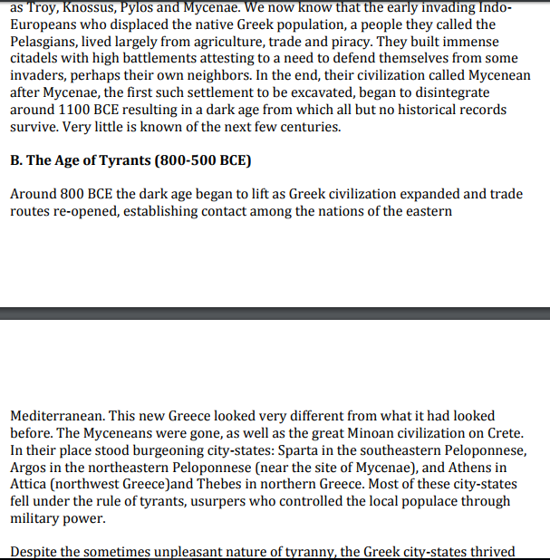

1. John C. (1990). Longman pronunciation dictionary. Harlow, England: Longman. ISBN 0-582-05383-8. entry "Augustus

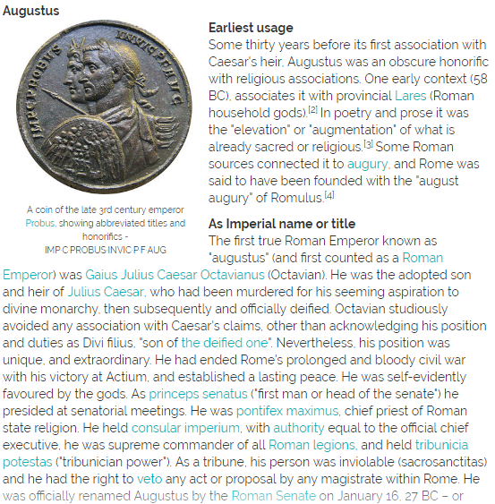

Citation 8 - entry "Augustus" Clifford, A. (2000) Imperial ideology and provincial loyalty in the Roman Empire: University of California Press

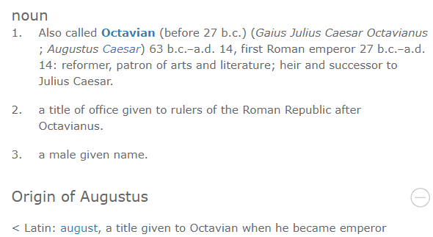

Citation not specific - Blackburn, Bonnie. (1999). The Oxford Companion to the Year. Oxford University Press: Reprinted with corrections

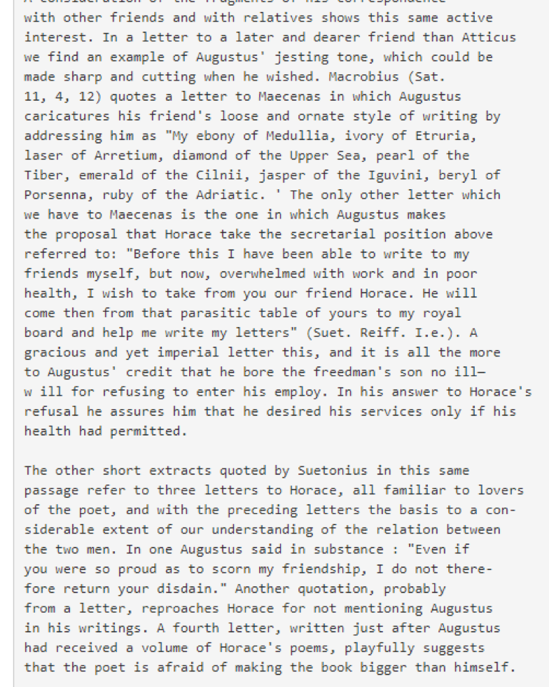

Citation Bourne, Ella (Bourne, 2000). "Augustus as a Letter-Writer", Transactions and Proceedings of the American Philological Association (Volume 49, 1918): 53–66.

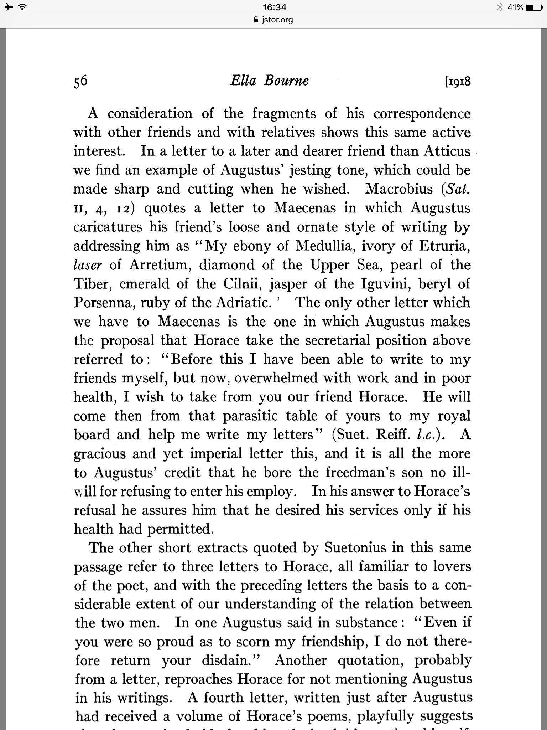

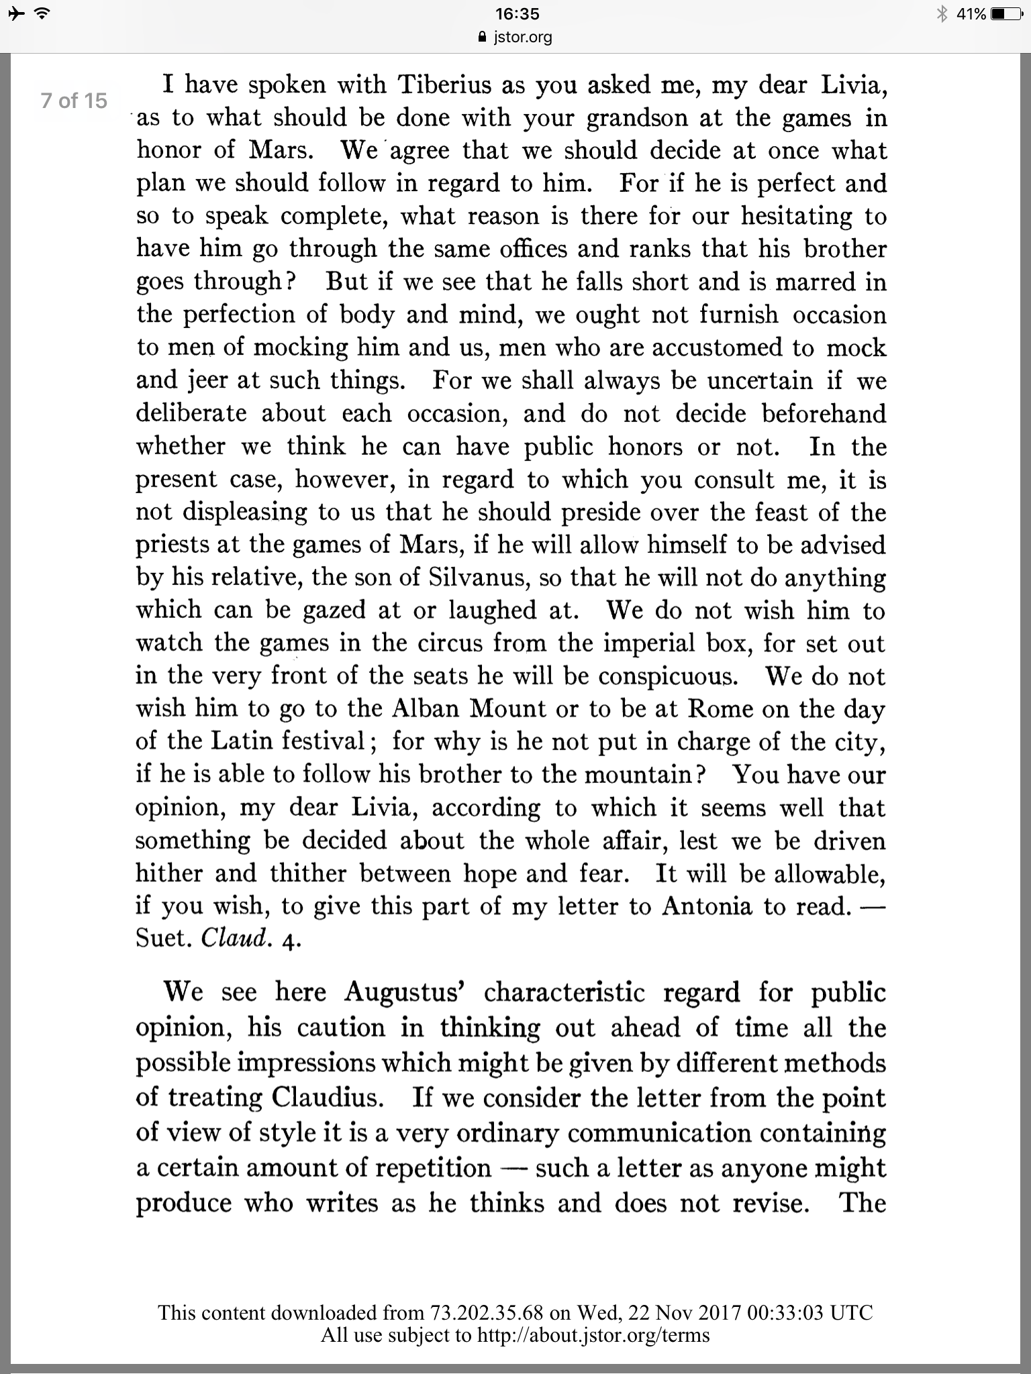

Citation not specific - Bowersock,. W. (1990). "The Pontificate of Augustus": ISBN 978-0-520-08447-6.

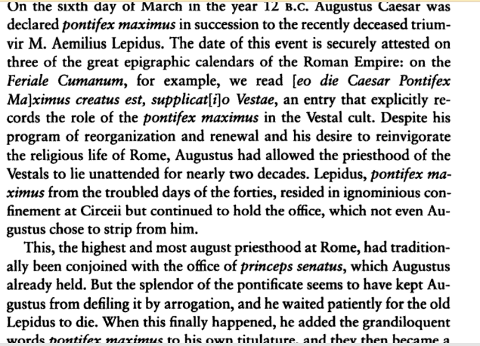

Citation not specific- Maria, B. (2006). The Persians: An Introduction. London & New York: Routledge. ISBN 978-0-415-32089-4 pp.538